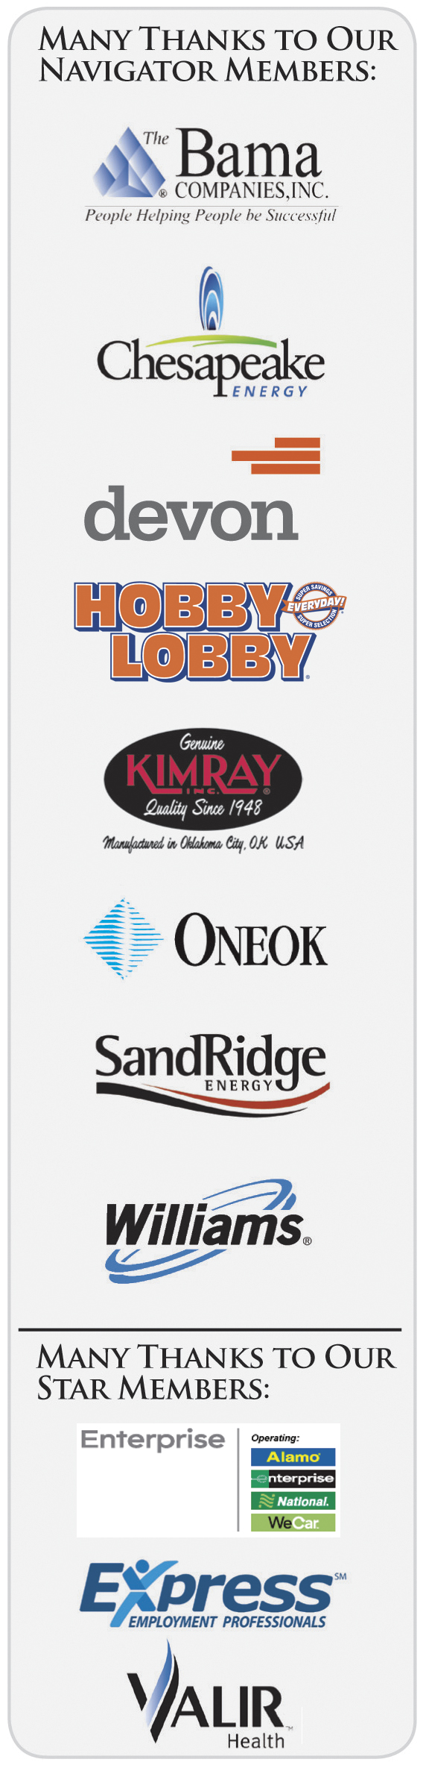
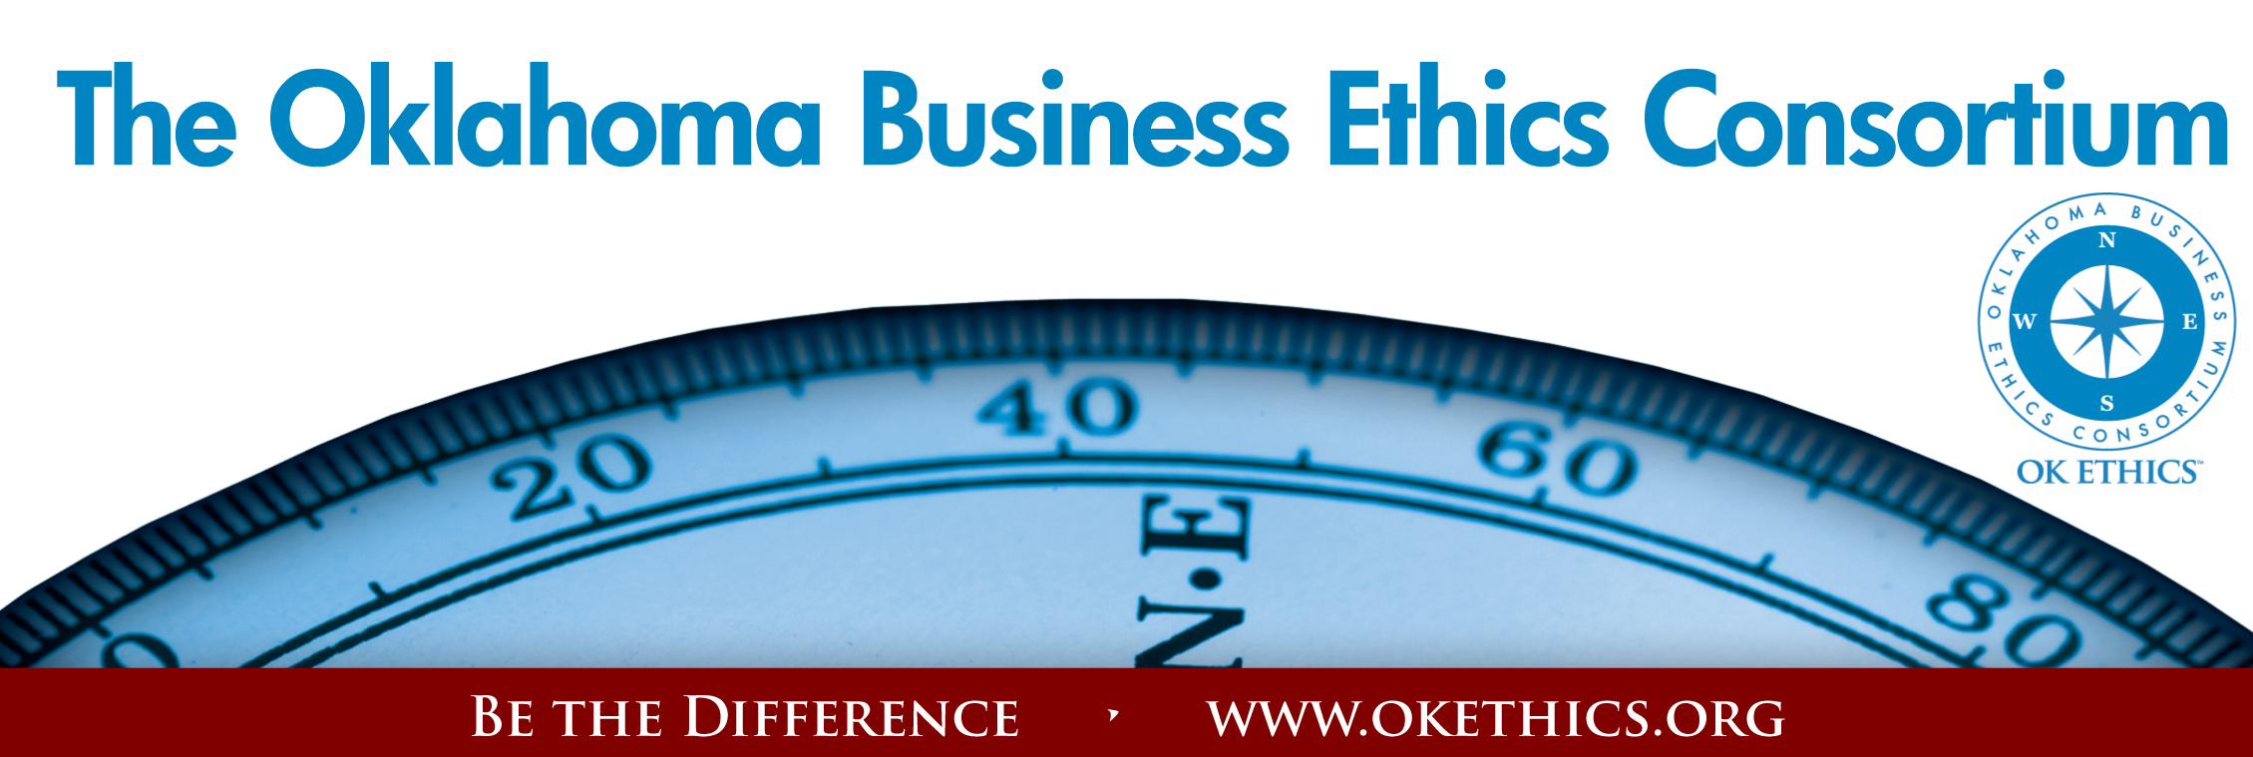
Agenda
December 9, 2009
I. Welcome & Kudos Todd Lisle, Advisor
OK Ethics Consortium Board of Directors
Managing Partner (Oklahoma); BKD, LLP
Volunteers:
Greg Byers, Sinclair Broadcasting – Registration Chair
Mary Kay Huggard, Principal Technologies – Registration Co-Chair
Registration Team: Ashley Warne, Principal Technologies; Becky Cavnar, OBU International Graduate School; Joe Walker, Grant Thornton
Tere Bettis, Coppermark Bank – Chief Ambassador
Ambassadors: Linda Streun, Ideal Homes; Shannon Hiebert, Enterprise Rent-A-Car; Debbie Gardner, Accel Financial Staffing Specialists, Brent Martens, Accounting Principals and Mary Vaughn.

Want to volunteer? Let us know! Call Shannon Warren at 858-2233.

Bobby Redinger, Cole & Reed - Agendas
Linda Manaugh, Metro Technology Centers – Handouts
Edith Steele, Oklahoma Accountancy Board - CPE Certificates
Connie Storey, Maximum Multi Media Creations –PowerPoint
Special thanks to Member Care Coordinator, Deborah Gavula

Mark your calendars: On January 13, we will be honoring our special volunteers and Board members who have lead
OK Ethics into our SIXTH year!

Book Sales:
Thanks to Becky Cavnar (OBU) and Mark Neumeister (D.R. Payne) for handling this for OK Ethics.
Note: In exchange for waiving his normal speaker’s fees, we
have agreed to provide an opportunity for participants to buy Mr. Johnson’s book at a cost of $10 each. He will be available for a book-signing immediately after the program. (You can also buy The “Dear Office Politics” book for $30 apiece.)

II. ANNUAL COMPASS AWARDS – COMING SOON!
Co-Chairs: Edith Steele, Oklahoma Accountancy Board
Mike Strong, Oklahoma Quality Award Foundation
- Start early – download last year’s applications on our website at www.okethics.org ; Nominate a company that models Oklahoma standards of integrity at work.
III. CPE CERTIFICATES
***IMPORTANT*** CPE Certificates must be signed and picked up at the conclusion of this event. Sorry, but we cannot email these later.

- Congratulations to our Student Ethics Bowl Participants! Bob Byrne, Advisor
OK Ethics Board of Directors
UNIVERSITY OF CENTRAL OKLAHOMA | OKLAHOMA CITY UNIVERSITY
Dr. Katherene Terrell - Advisor | Dr. Barbara Crandall
Olga Miranova (Nextep, Inc.Scholarship Recipient) | Drew McNichols
Christopher Scifies | Maria Perezmachecha
Daniel Thompson | John Riesenberg
 | Bridget Shuck (Chesapeake Scholarship Recipient)

Many thanks to Enterprise Rent-A-Car for the grant that made this opportunity possible.

A Special Invitation:
OK Ethics Foundation has offered to send Dr. Terrell, Dr. Crandall and Dr. Stephen Rockwell (TU) to the National Ethics Bowl in Cincinnati on March 4 -7. We want to observe with the intention of bringing a regional ethics bowl to Oklahoma. If you are interested in helping with this initiative and can obtain funding from your organization for this trip, please contact OK Ethics Foundation President, Pam Fountain at pfountain@principaltechnologies.com.

Welcome students:
Universities/Colleges: | Corporate Sponsors:
OBU International Graduate School | Chesapeake Energy
Oklahoma City University | Enterprise Rent-A-Car
Rose State College | Express Employment Professionals
Southern Nazarene University | Kimray, Inc.
University of Central Oklahoma
University of Oklahoma

V. INTRODUCTION OF KEYNOTE SPEAKER Donna Miller, Executive Resource Center LLC
“Ethics & Office Politics”
Featuring author Timothy L. Johnson
VI. UPCOMING EVENTS Shannon Warren, Founder
Oklahoma Business Ethics Consortium Board of Directors
January 25 - UCO Student Ethics Chapter Monthly Meeting
“Ethics - Chesapeake Style”
Discussion of the types of ethical issues dealt with and the tools developed for solutions.
Monday, January 25, 2010 - 2:30 p.m. (2:00 p.m. Social)
Troy Smith Lecture Hall, UCO College of Business, B113
Guest Speaker: Tony Blasier
Ethics Officer for Chesapeake Energy Corporation
Please contact Dr. Katherene Terrell for parking pass at kterrell@uco.edu

JOIN OK ETHICS
- Join today – go to www.okethics.org or call 889-0498
- Do you know someone who has been laid off?
OK Ethics is offering a free Scout membership (value of $75) to any business professional who has been recently impacted by a reduction-in-force. See the website or call 858-2233 for more details.

January 13 – “Native American Wisdom”
Oklahoma Sports Hall of Fame & Jim Thorpe Museum; Oklahoma City

February 13 – David Prater, Oklahoma District Attorney
 | 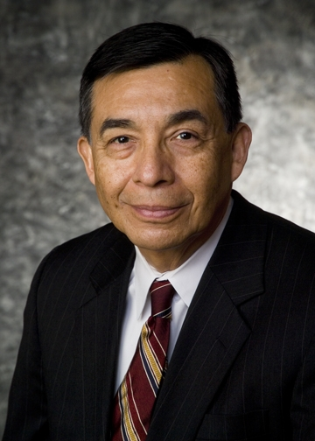 | 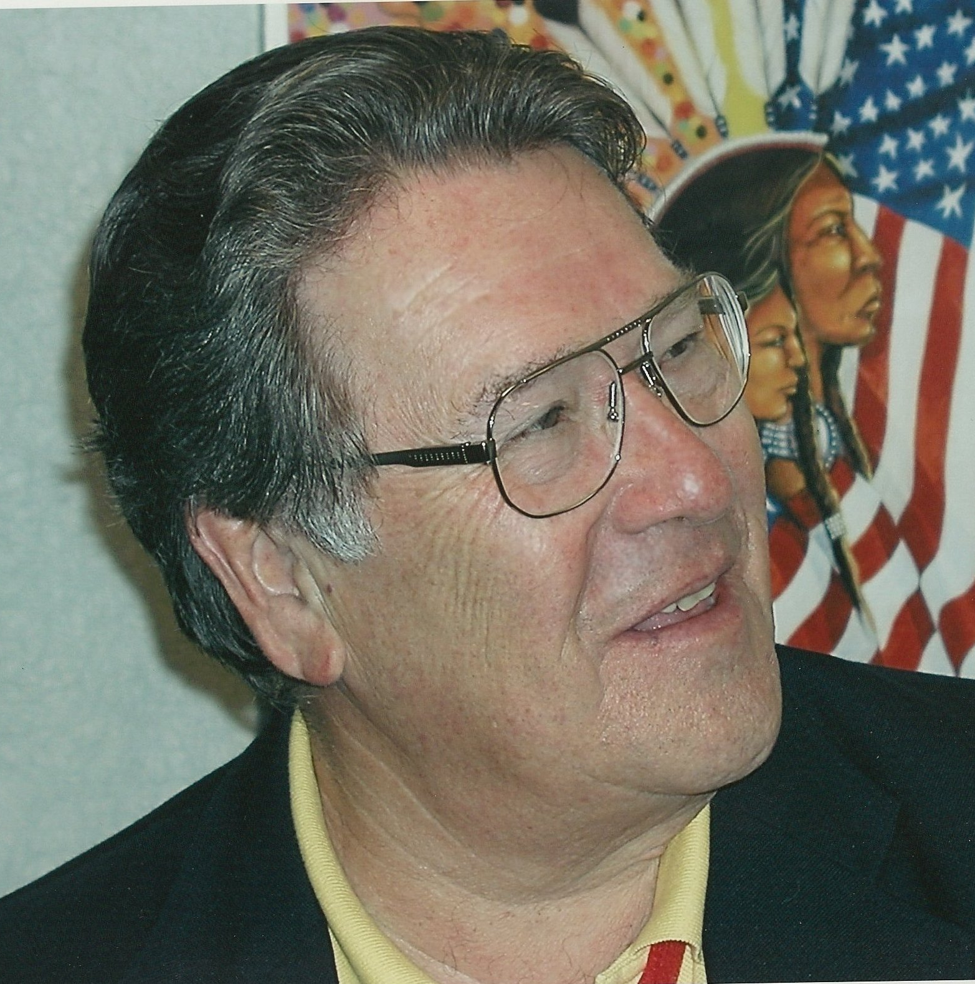 | 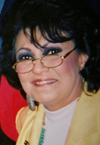
Facilitator:  Dr. James Collard  Citizen Potawatomi Nation  Director of Planning and Economic Development | Kirke Kickingbird  Kiowa  Attorney  Hobbs, Straus, Dean & Walker, LLP | Jack Thorpe  Sac & Fox  Son of Oklahoma athlete, Jim Thorpe  Executive Director  Sac and Fox Housing Authority | Barbara Warner  Ponca  Executive Director Oklahoma Indian Affairs Commission
Kudos to new OK Ethics Board member Tony Blasier of Chesapeake for making these arrangements.
TULSA CHAPTER WELCOMES OUR FIRST INTERNATIONAL SPEAKER:
Management and Ethics in a Web 2.0 World & Beyond | January 28  Tulsa Southern Hills Marriott
The changes brought on by the internet revolution continue to redefine many aspects of our lives, both on the job and at home. The introduction of Web 2.0 technologies marks the beginning of a new phase in the evolution of the workplace that will have broad implications on how managers interact with their employees. Asher Adelman, a great workplace entrepreneur, will share some of these major trends and will discuss how blogs, social networking, and even Google will impact ethical dilemmas, define workplace relations, and alter the boss-employee relationship. His presentation will examine the threats that companies will encounter if they fail to recognize and adjust to these seismic changes.  Asher will also explore innovative workplace branding strategies that will help companies and managers prepare for these impending changes, gain a competitive advantage in their markets, and ensure the loyalty of their employees, customers, and shareholders. | 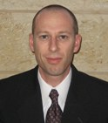  Asher Adelman  Founder of eBossWatch.com

VII. OTHER EVENTS RELATED TO INTEGRITY AT WORK
OK Ethics is honored by our friendship with the Character First! Institute.
They provided wisdom and the basis for our Guiding Principles.
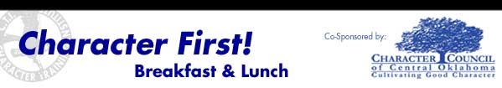

Thursday, December 17 - Punctuality vs. Tardiness
"Showing esteem for others by doing the right thing at the right time."
Presented by: Tom Hill, founder of Character First! and CEO of Kimray
Please RSVP by calling 815-0001 or Email for more information: blb@characterfirst.com
Cost is $10 per person
January 2010 - Resourcefulness:
Breakfast - Jan. 28, 2010 (Thursday)
Lunch - Jan. 28, 2010

General Disclaimer: Members of the Oklahoma Business Ethics Consortium frequently share information concerning various issues and developments that may have legal implications. The discussions, commentary, and handouts at Consortium meetings
or presentations to other organizations are for general informational purposes only. They cover only some aspects of the subject topic, and do not constitute a complete legal analysis of the topic or how it might apply to any particular set of facts. Before taking any action based on information presented during a Consortium event, participants are encouraged to consult a qualified attorney.

The observations and comments of presenters at Consortium meetings and networking are the views and opinions of the presenter and do not constitute the opinion or policies of the Consortium or any of its members. Presenters are respectfully requested to avoid profanity, preaching, politics and self-promotion during their lectures.
CPE CERTIFICATES
It is the responsibility of participants to demonstrate applicability of each program for demonstration of earned CPE credits, to his/her area of practice. OK Ethics makes no guarantees. Also, attendees must be present to accept CPE certificate at the conclusion of the program.

CPE CERTIFICATES WILL BE ISSUED AT THE BACK OF THE ROOM AT THE CONCLUSION OF THIS EVENT
NOTE THAT WE WILL NOT EMAIL THESE

YOU MUST BE REGISTERED ON OUR ATTENDANCE LIST TO
RECEIVE A CERTIFICATE

