Oklahoma Business Ethics Consortium
March 8, 2006 ~ 11:30 to 1:00
Agenda

I. Welcome & Guiding Principles 11:45
- Blaine Rider
Digital West Productions

In order to maintain OkEthics’ culture and promote integrity in our organization, we routinely begin our meetings
with reflections about our Guiding Principles. Today’s focus on HUMILITY is based on the following principle:
“Realizing that each of us is in a mode of continual learning, we demonstrate humility, care and compassion when sharing our thoughts and knowledge.”

II. Kudos - Shannon Warren, Founding Director, OkEthics
    - Connie Barwick, Maximum Multi-Media Creations (PowerPoint)
    - Tammy Wood, Valir Health (Nametags)
    - Students, Hosts, TU Ethics Challenge Judges, Scholarship Criteria Committee

- S.O.S. HELP WANTED!
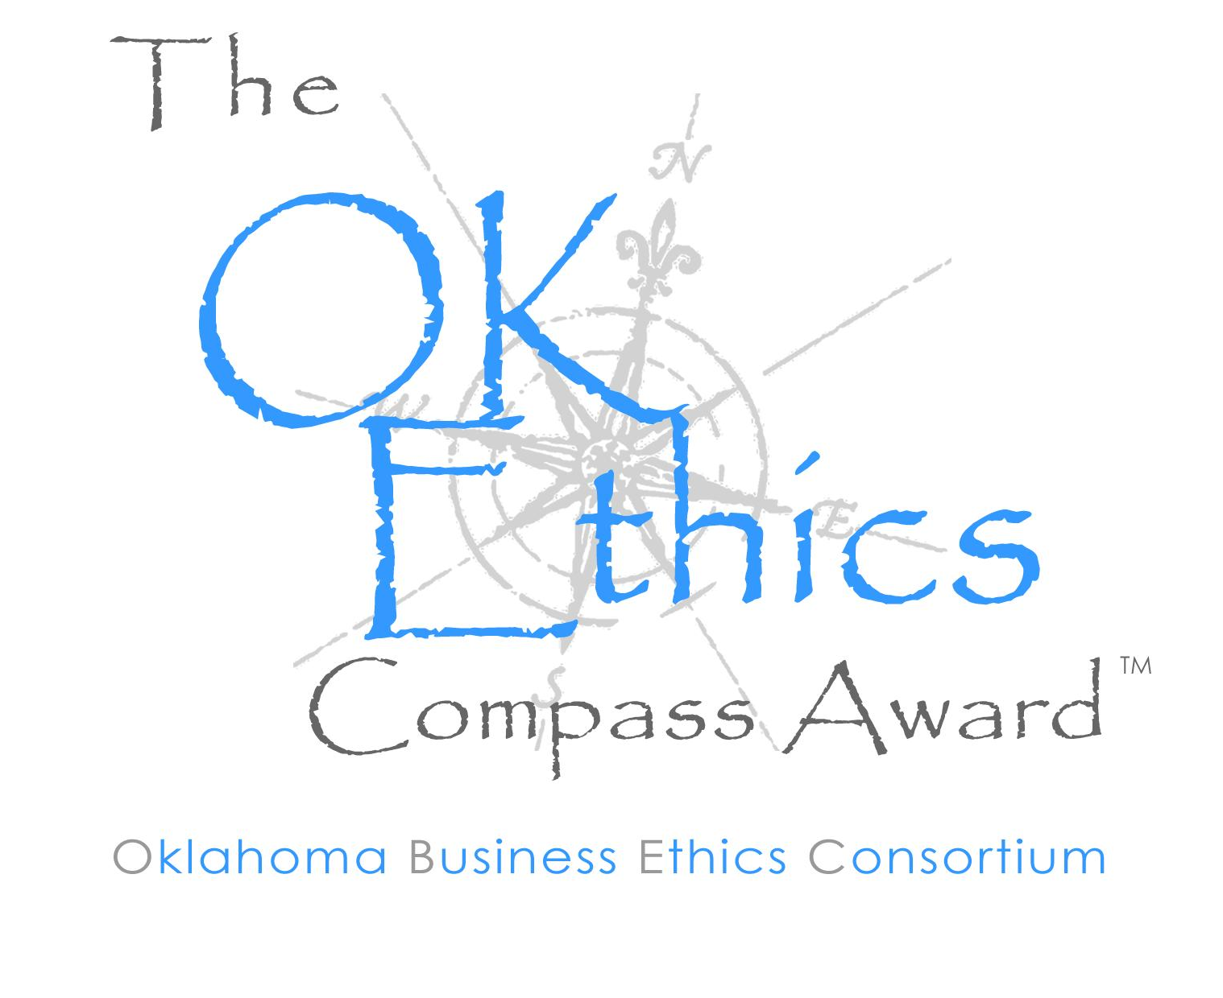
Growing Pains! We need bookkeeping services and help with registration.
Call 858-2233.

- OKETHICS COMPASS AWARD
- Nominees – Available on-line
- Self-nominations are encouraged!
- MARK YOUR CALENDARS FOR LUNCHEON - APRIL 24
Sponsorships are available:
$ 950 – Inclusion as a sponsor; logo displayed in advertisements for event.

$ 600 – Table sponsorship for 8 participants to attend event.
(See special discounts for small businesses and non-profit organizations.) Organizations at this level will be listed in event program.

$ 300 – Non-profit and small business (less than 50 employees) rate for table sponsorship.

$ 45 – Individual reservations for the luncheon event.

Contact Shannon Warren, OkEthics Founding Director, at (405) 858-2233 for details.
V. Upcoming Consortium Meetings

OKC Chapter
April 24 – SPECIAL OKETHICS COMPASS AWARD LUNCHEON
OKLAHOMA HISTORY CENTER
May 10 – Joe Castiglione, OU Athletic Director

MOORE-NORMAN CHAPTER MEETING:
Members in OKC chapter may participate in other Chapter activities at the regular member rate. To make reservations, visit our website at www.okethics.org

March 15 – Character Focus: “Responsibility” by Steven Menzel

TULSA CONSORTIUM MEETINGS:
March 23 – Stan Clark, Eskimo Joe’s

Other Programs Related to Ethics:
Character First – Business Leaders Breakfast/Luncheon
March 28 (breakfast) and March 30th (luncheon)
Location: Character First Institute, 520 West Main Street
RSVP: 815-0001 or visit the Character Council Website at http://www.characterok.org/

University of Central Oklahoma presents Cynthia Cooper
WorldCom Whistleblower and Time's 2002 Person of the Year
March 30; 3:00 - 4:30 Constitution Hall, Nigh Convention Center, UCO, Edmond, Okla
FREE TO OKETHICS MEMBERS!
Space Limited ~ ADVANCE REGISTRATION REQUIRED for parking passes and directions to event. Be sure to identify yourself as an OkEthics member!
Contact: Dr. Kathy Terrell, kterrell@ucok.edu

VII. OkEthics Foundation Scholarships Available – See website for details

VIII. Introduction Tom Michaud,
Foundation Surgery Affiliates

IX. Keynote Speaker Susan Savage Secretary of State

X. Adjourn 1:00

PLEASE HELP US CONTROL COSTS –
LEAVE YOUR NAME TAGS WITH US!

NOTE: Members of the Oklahoma Business Ethics Consortium frequently share information concerning various issues and developments that may have legal implications. The discussions, commentary, and handouts at Consortium meetings or presentations to other organizations are for general informational purposes only. They cover only some aspects of the subject topic, and do not constitute a complete legal analysis of the topic or how it might apply to any particular set of facts. Before taking any action based on information presented by a Consortium member, participants are encouraged to consult a qualified attorney. The observations and comments of presenters at Consortium meetings and networking are the views and opinions of the presenter and do not constitute the opinion or policies of the Consortium or any of its members.

