Oklahoma Business Ethics Consortium
February 8, 2006 ~ 11:30 to 1:00
Agenda

I. Welcome & Announcements 11:45
- Shannon Warren
OkEthics Founding Director

II. Kudos
    - Ray Roush – Chesapeake Energy; STAR member
    - Scott Klososky – Future Point of View (Consulting for website)
    - Justin Meek & Kari Snyder – Cicero International Advertising (Compass logo)
    - Diana Wall & Sandy Patton – Accel Financial Staffing (Financial statements)
    - Myrna Schack Latham & Brad Klepper – McAfee Taft (Trademark)
    - Connie Barwick, Dept. of Corrections (PowerPoint)
    - Rick Spring, Home Entertainment Systems, Inc. (AV Equipment)
    - Tammy Wood, Valir Health (Nametags)
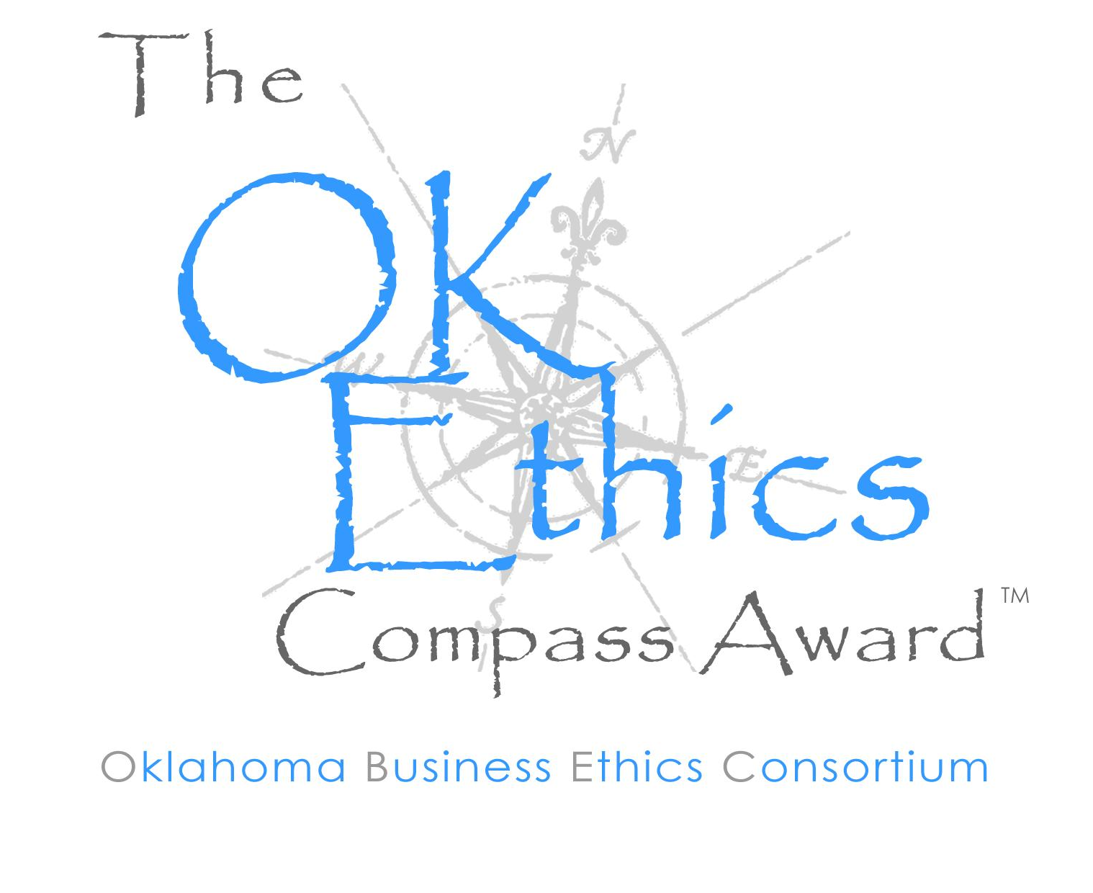
- OKETHICS COMPASS AWARD
- Nominees – Available on-line next week; can nominate someone today!
- Self-nominations are encouraged!
Sponsorships are available:

$ 950 – Inclusion as a sponsor; logo displayed in advertisements for event.

$ 600 – Table sponsorship for 8 participants to attend event. (See special discounts for small businesses
and non-profit organizations.) Organizations at this level will be listed in event program.

$ 300 – Non-profit and small business (less than 50 employees) rate for table sponsorship.

$ 45 – Individual reservations for the luncheon event to be held in late April.
(Date to be determined.)

Contact Shannon Warren, OkEthics Founding Director, at (405) 858-2233 for details.
III. Upcoming Consortium Meetings

OKC Chapter
March 8 – Susan Savage, Oklahoma Secretary of State
April – WATCH FOR OKETHICS COMPASS AWARD SPECIAL LUNCHEON
May 10 – Joe Castiglione, OU Athletic Director

MOORE-NORMAN CHAPTER MEETING:
Members in OKC chapter may participate in other Chapter activities at the regular member rate. To make reservations, visit our website at www.okethics.org

February 15 – Jim Priest, Attorney with Whitten, Nelson & McGuire, “Playing with Fire” –
Even though Oklahoma is in the midst of a burn ban, many Oklahomans are playing with fire! Because when you strike the match of romance in the workplace the flames can quickly get out of control. Don’t get burned! A former president of a Fortune 500 company resigned last year after his affair with a subordinate leaked out. Sexual harassment lawsuits abound when co workers engage in too much “hands-on” training. Learn about the perils of puckering up, the menace of a motel room, and the roiling havoc created by a roll in the hay when you hook up with someone in workplace.
Workplace romances: illegal, unwise or just a fact of life? Find out February 15!

TULSA CONSORTIUM MEETINGS:
February 23 – “Ethics in the News Business”
Tulsa World Managing Editor, Susan Ellerbach &
Business Editor, John Stancavage

March 23 – Stan Clark, Eskimo Joe’s

Other Programs Related to Ethics:
Character First – Business Leaders Breakfast/Luncheon
Topic: “Tolerance in the Workplace”
Dates & Times: Tuesday, February 28 7:00 a.m. – 8:00 a.m.
Thursday, March 2 Noon to 1:00 p.m.
Location: Character First Institute, 520 West Main Street
Cost: Complimentary
RSVP: 815-0001 or visit the Character Council Website at http://www.characterok.org/

Sue Hale, Editor of The Oklahoman will be conducting a book signing “Nursing Home Diary:
A Lesson in Survival” on February 23 at The Fountains at Canterbury, 1402 NW 122nd; Contact Debie Weaver at 751-3600 to attend the event free of charge.

IX. Introduction Brent Gooden,
The Gooden Group

X. Keynote Speaker Paul Mott, President
The Hornets

XI. Adjourn 1:00

PLEASE HELP US CONTROL COSTS –
LEAVE YOUR NAME TAGS WITH US!

NOTE: Members of the Oklahoma Business Ethics Consortium frequently share information concerning various issues and developments that may have legal implications. The discussions, commentary, and handouts at Consortium meetings or presentations to other organizations are for general informational purposes only. They cover only some aspects of the subject topic, and do not constitute a complete legal analysis of the topic or how it might apply to any particular set of facts. Before taking any action based on information presented by a Consortium member, participants are encouraged to consult a qualified attorney. The observations and comments of presenters at Consortium meetings and networking are the views and opinions of the presenter and do not constitute the opinion or policies of the Consortium or any of its members.

OK-ETHICS MEMBERS: THANK YOU FOR LIGHTING THE WAY!

OKLAHOMA STARS




leading members
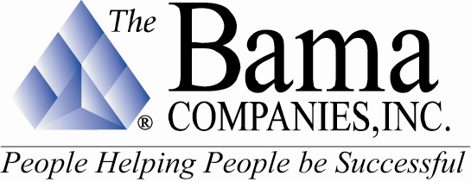
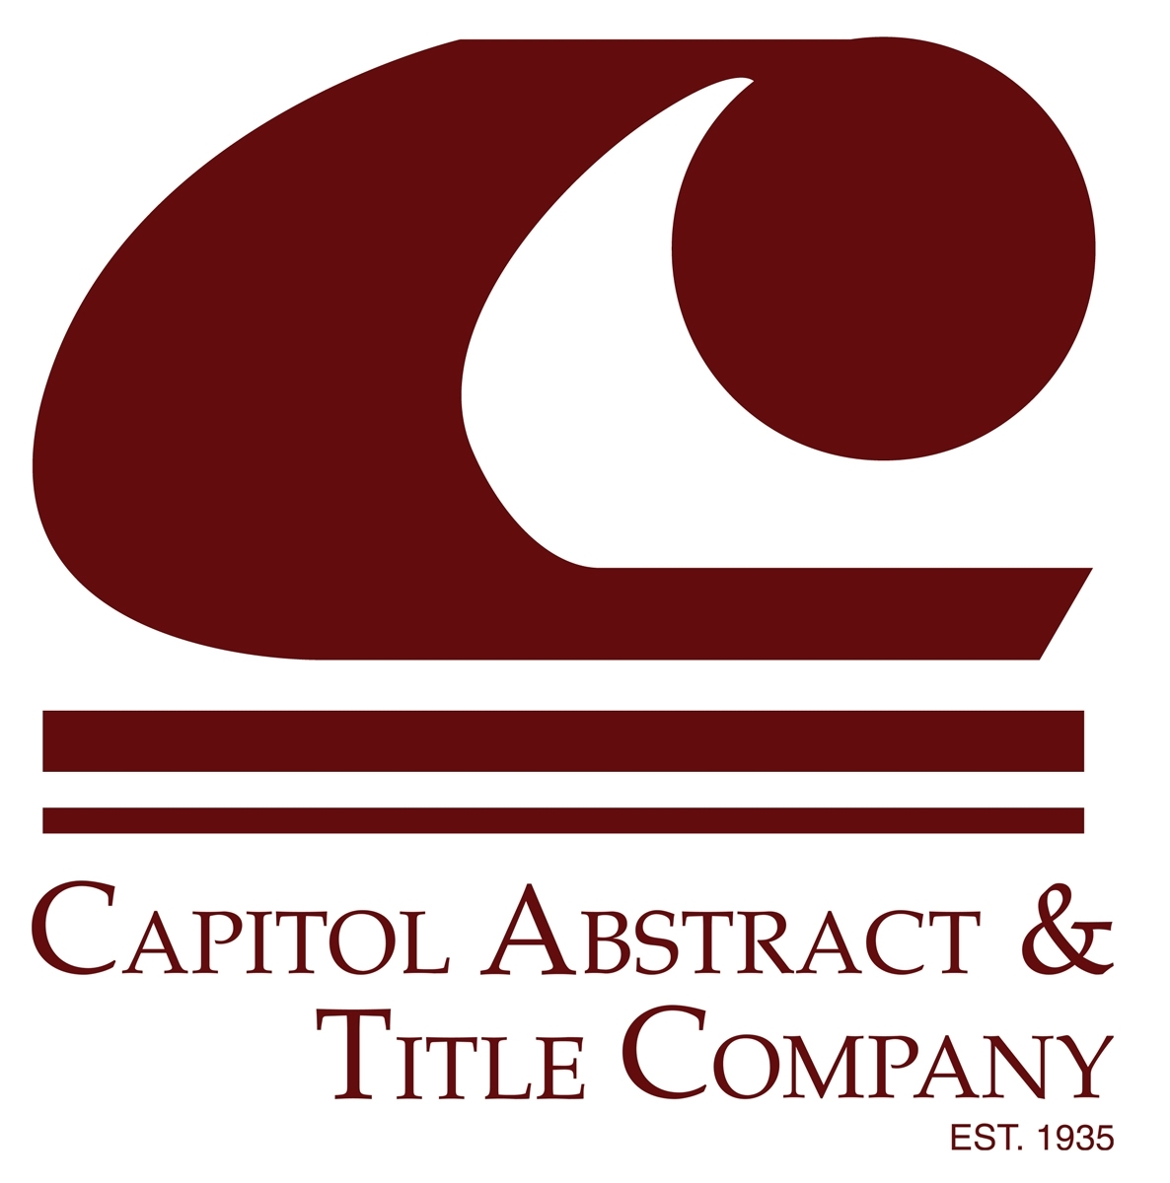



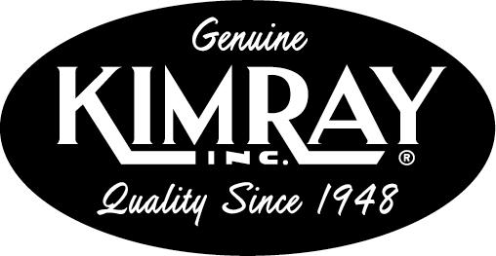
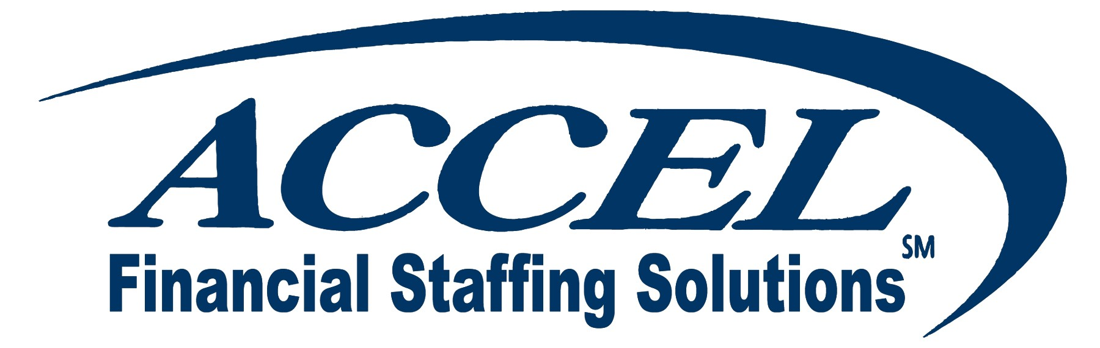


(Tulsa)

Sustaining Members:

Bill Bleakley, OKCBusiness Roger Hicks, Hicks & Associates
Stan Martin, HealthHistories, Inc. Blaine Rider, Digital West

Fellowship Members:

Jacque | Bergman | Kerr-McGee,
Lynnda | Berryhill | Berryhill Insurance Agency. Inc.
Myrna S. | Latham | McAfee & Taft
Mary | Melon | The Journal Record
David | Rhoades | Fraud & Forensic Investigations
Shannon | Warren | Warren Consulting LLC
Debie | Weaver | The Fountains at Canterbury

CORPORATE MEMBERS:

Beale Professional Services
Boeing Company, The
Busey Group, The
Cole & Reed
CoorsTek
Coppermark Bank
Cox Communications - Oklahoma
Edward Jones (OKC)
Edward Jones Investments (Tulsa)
Enterprise Rent-A-Car
Epworth Villa Life Care Community
EWF International
Foundation Surgery Affiliates. Inc.
Gooden Group. Inc., The
Gray & Company. P.C. CPAs
Greater OKC Hispanic Chamber
Hogan & Slovacek
Holy Trinity Charismatic Episcopal Church
Langston University/Oklahoma City
Leader Communications. Inc.
Lisle Compton Cole & Almen LLP
Metro Technology Centers
Moore Norman Technology Center
Norris
Oklahoma Center for Non-Profits
Oneok. Inc.
Sharron’s Designs
Staffmark
State Chamber of Oklahoma
Third Degree Advertising
University of Central Oklahoma
University of Oklahoma
College of Arts and Sciences
University of Tulsa. The
Valir Health
Williams Companies
Woodrum Kemendo & Cuite

We are unable to list individual members at this time. If you do not see your name on this list and have already renewed or joined at the Corporate level and above, please notify Shannon Warren at (405) 858-2233 as soon as possible so that we may make corrections.
Thank you for your patience!

TO JOIN THE OKLAHOMA BUSINESS ETHICS CONSORTIUM,
VISIT OUR WEBSITE AT HTTP://WWW.OKETHICS.ORG

